TASK ON DOCKER -02
- Create a tomcat container on 8080 and deploy sample application in tomcat.
Created a tomcat container and followed the steps shown in the below image:
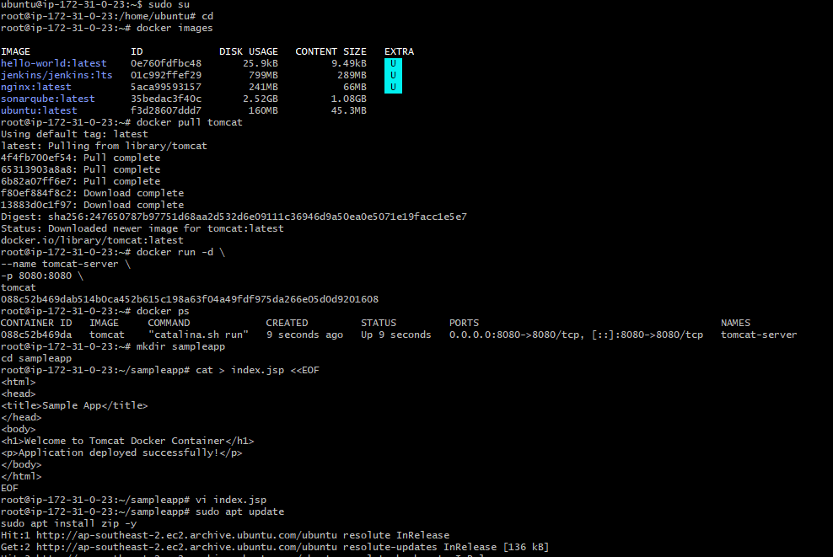
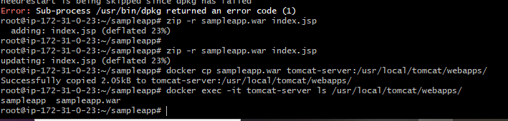
Checked with the IP address :8080 and sample app name:
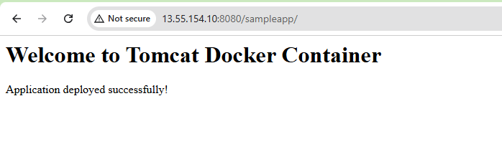
- Create volume and deploy tomcat container on port 8081.
> Create Docker Volume
docker volume create deployment
> Verify Volume
docker volume ls
> Check Volume Location
docker volume inspect deployment
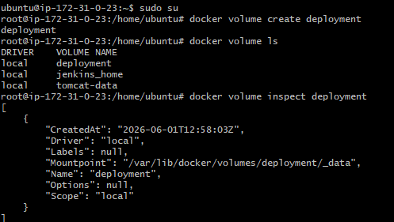
> Download Sample WAR File into Volume
cd/var/lib/docker/volumes/deployment/_data
wget https://tomcat.apache.org/tomcat-7.0-doc/appdev
/sample/sample.war
Ls -ltr
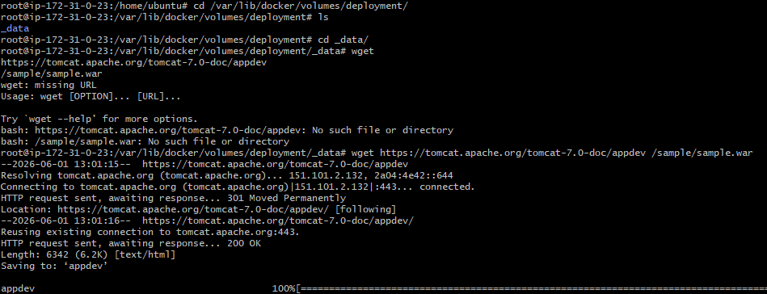
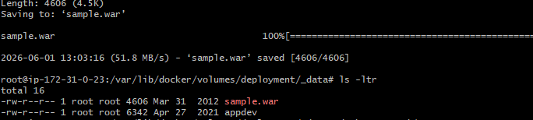
> Deploy Tomcat Container Using the Volume
docker run -d \
--name tomcat-volume \
-p 8081:8080 \
-v /var/lib/docker/volumes/deployment/_data:/usr/local/tomcat/webapps \ tomcat:latest
> docker ps
> Verify Deployment Logs
docker logs tomcat-volume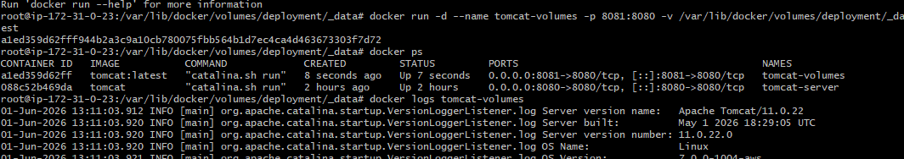
curl -I http://localhost:8081/sample
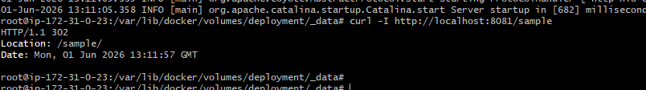
> Successfully created a Docker volume and
deployed a Tomcat container on port 8081.
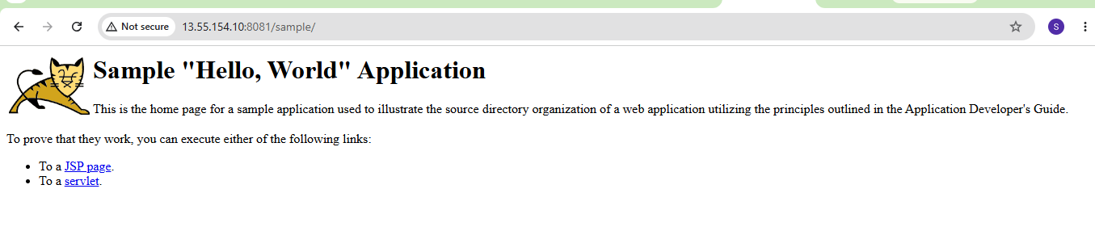
- Limit the nginx container to 500 MB.
>Pull Nginx Image
docker pull nginx:latest
docker images
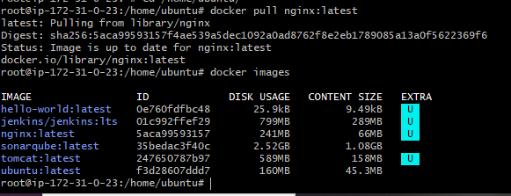
> Run Nginx Container with Memory Limit
Command
docker run -d \
--name nginx-limit \
-p 8082:80 \
--memory=500m \
nginx:latest
docker ps
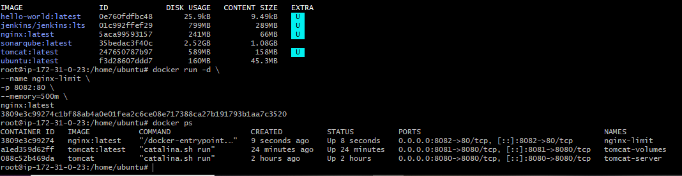
> verified the limit using the docker stats command.
docker stats
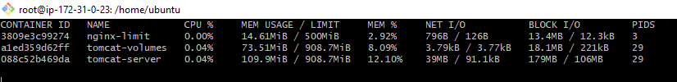
> Successfully created an Nginx container with a
memory limit of 500 MB.
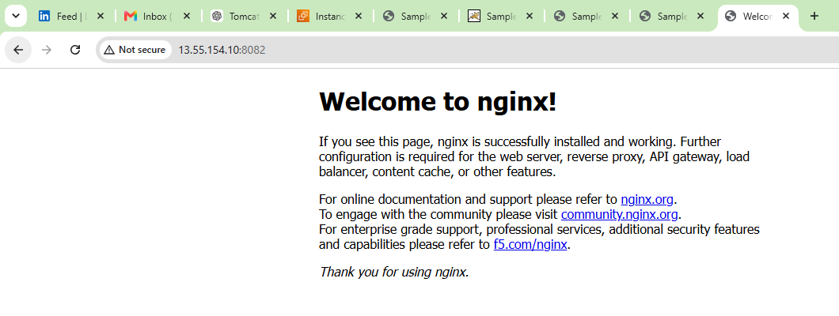
- Create a sample docker file using below instructions.
  - Base module as amazon linux:latest
  - Maintainer you name
  - Install nginx
  - COPY one index.html file to image
  - Expose on port 80
  - Command to start the nginx container:
> Create index.html
vi index.html
> Create Dockerfile
vi Dockerfile
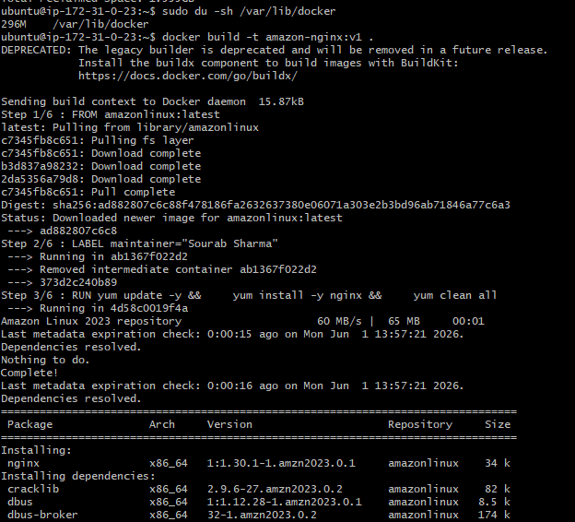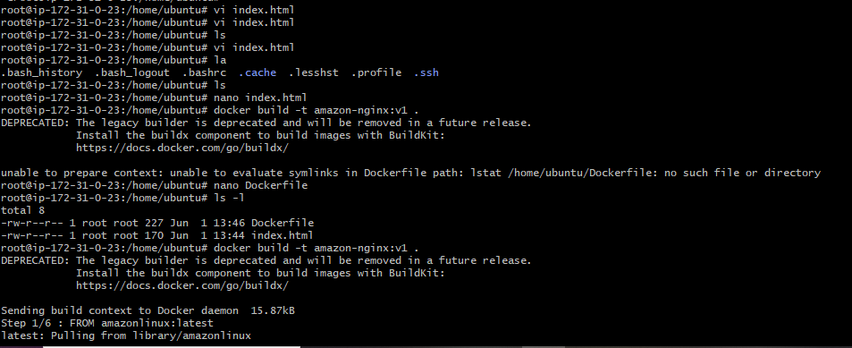
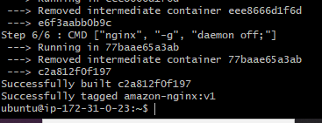
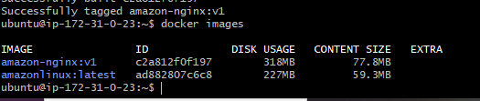
> Run Container
docker run -d \
--name nginx-custom \
-p 8083:80 \
amazon-nginx:v1
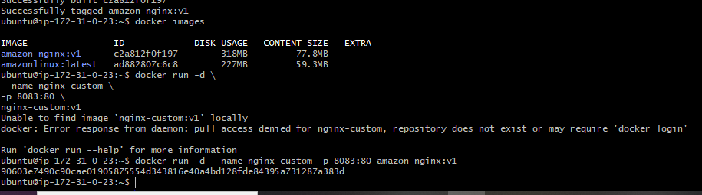
docker ps
> Successfully created a custom Docker image using a
Dockerfile with amazonlinux:latest, installed Nginx, and
copied a custom index.html file.
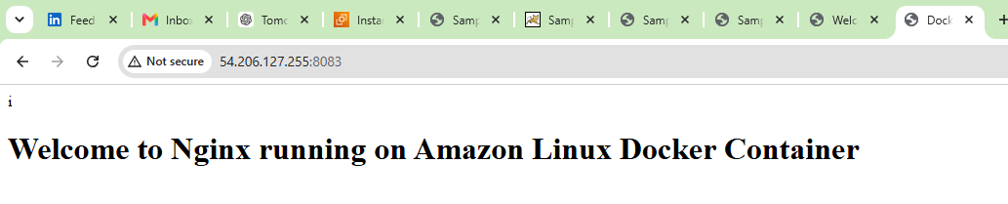
- Push image to Docker hub
docker login
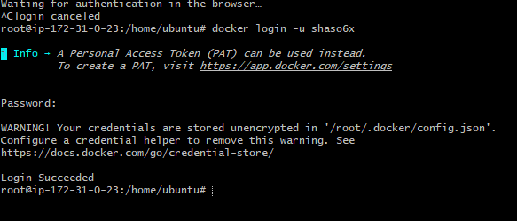
> Created a docker account
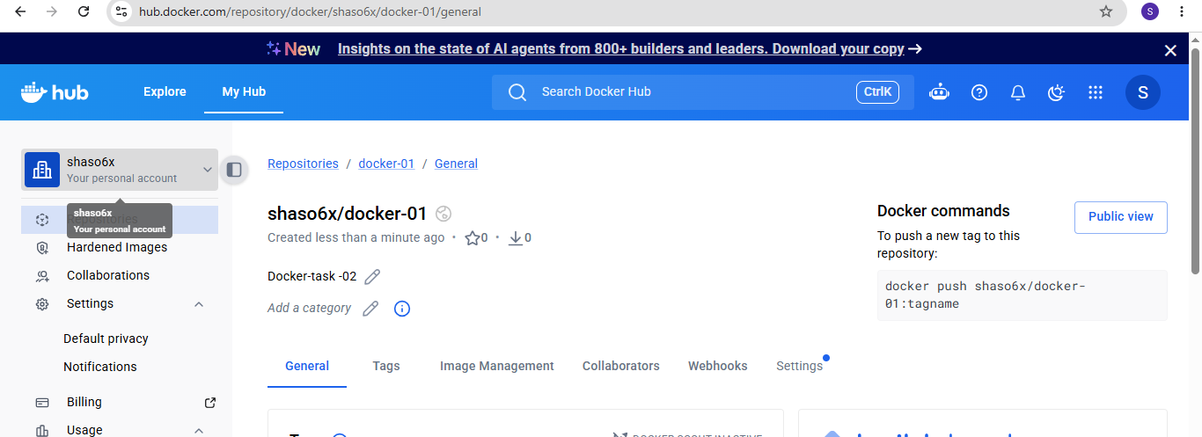
docker tag amazon-nginx:v1 shaso6x/amazon-nginx:v1
docker images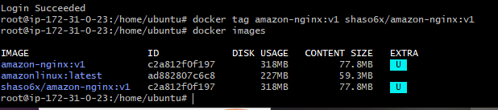
docker push shaso6x/amazon-nginx:v1
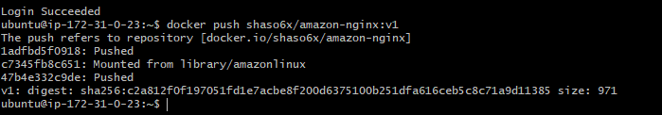
> Successfully Pushed image to Docker hub
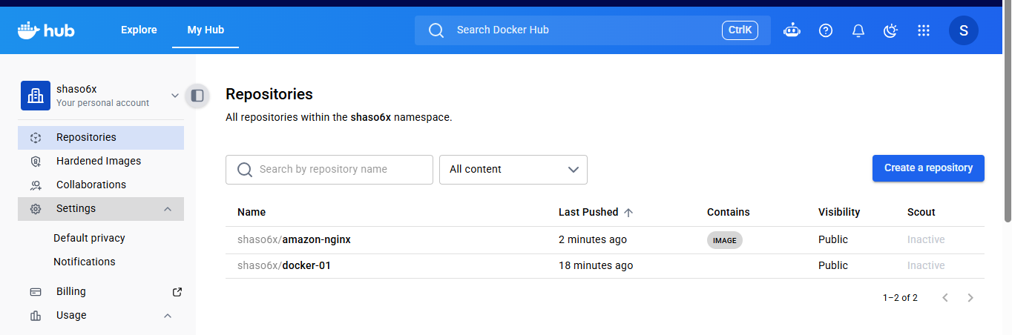
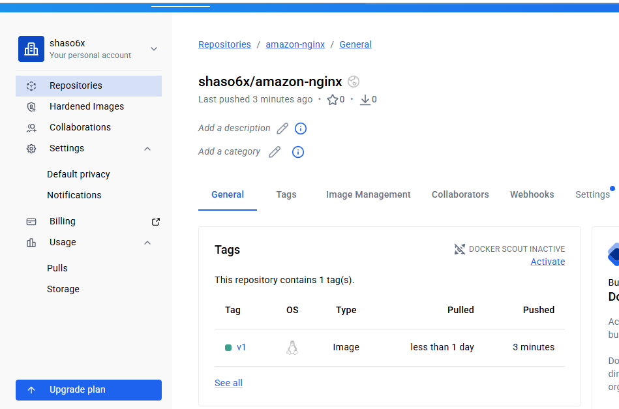
- push image to AWS ECR
apt install awscli -y
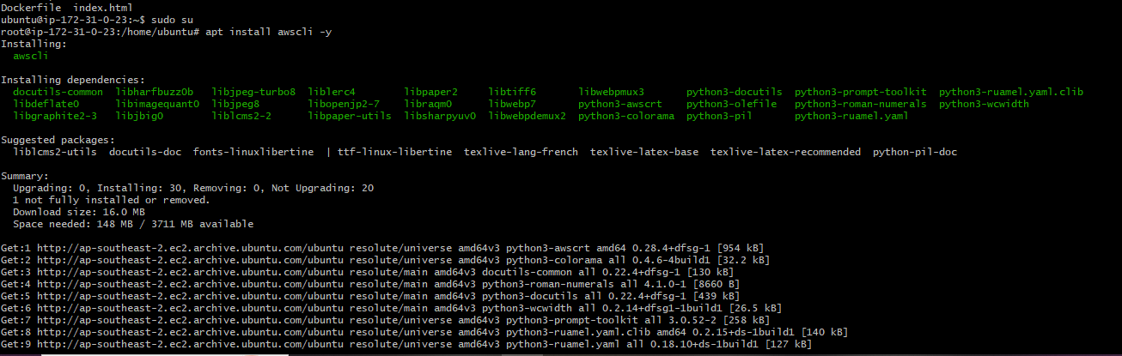
aws –version
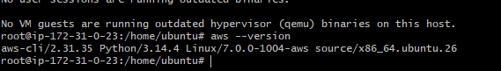
aws configure
aws sts get-caller-identity
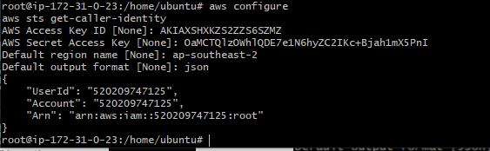
> login to aws ECR
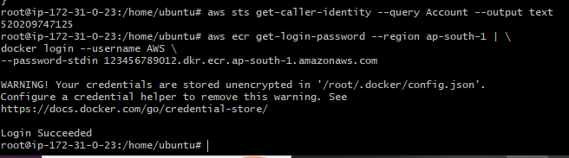
aws ecr create-repository --repository-name custom-nginx
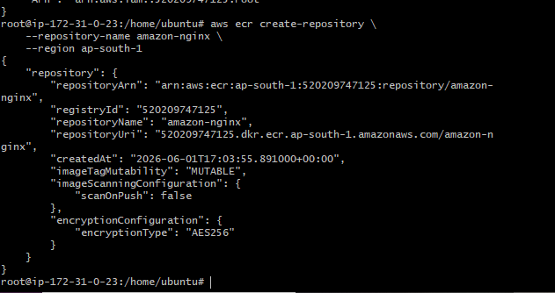
docker tag amazon-nginx:v1 520209747125.dkr.ecr.ap-southeast-2.amazonaws.com/amazon-nginx:v1
docker images
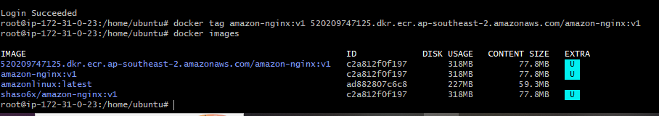
docker push 520209747125.dkr.ecr.ap-southeast-2.amazonaws.com/amazon-nginx:v1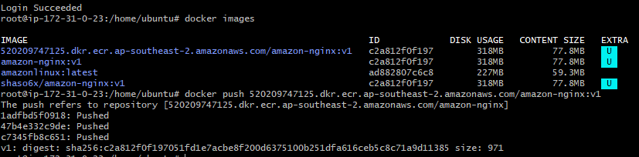
Pushed image successfully
